Docker Task – 2
Task Description:
Create a docker file, docker-compose file which when executed must display your basic details in the website.
- Created the EC2 instance in AWS
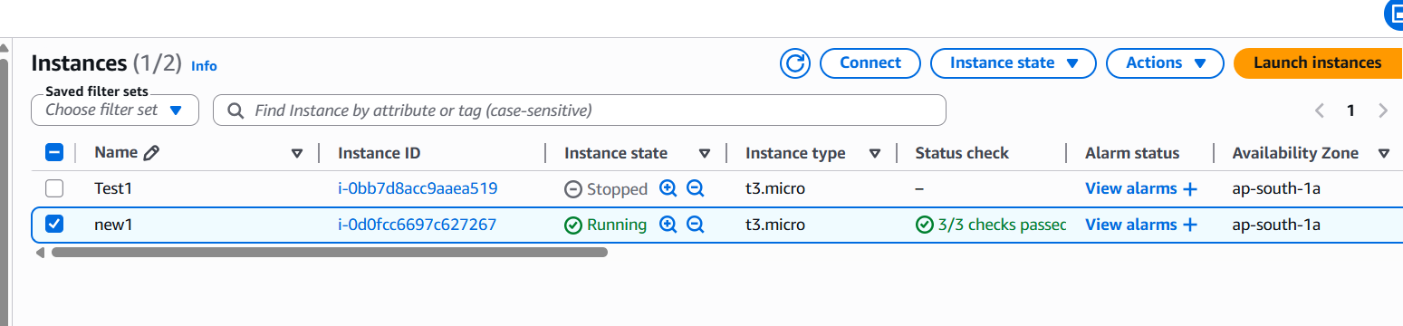
- And created a new directory docker-profile-app
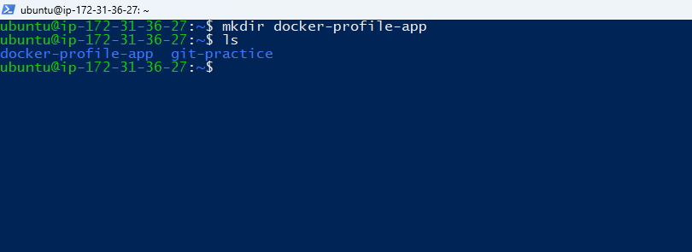
- Created a HTML file naming index.html, docker file, and docker-compose.yml file
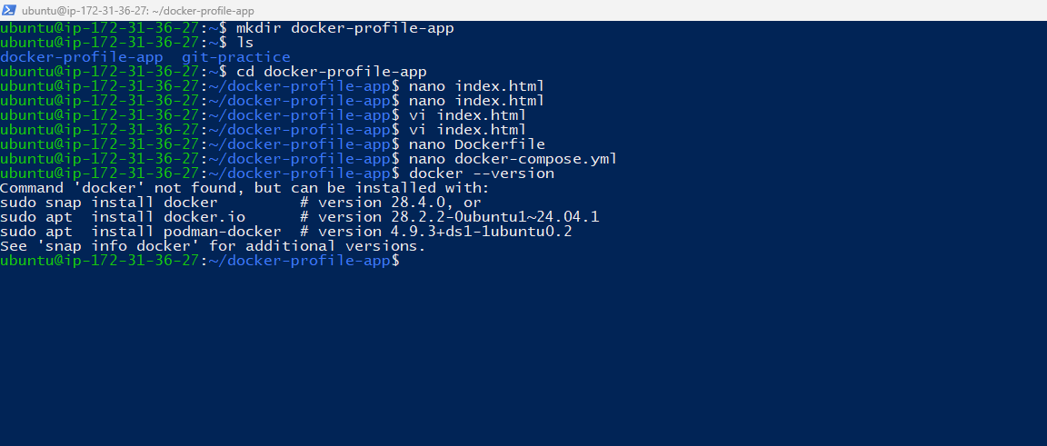
- Built and run docker
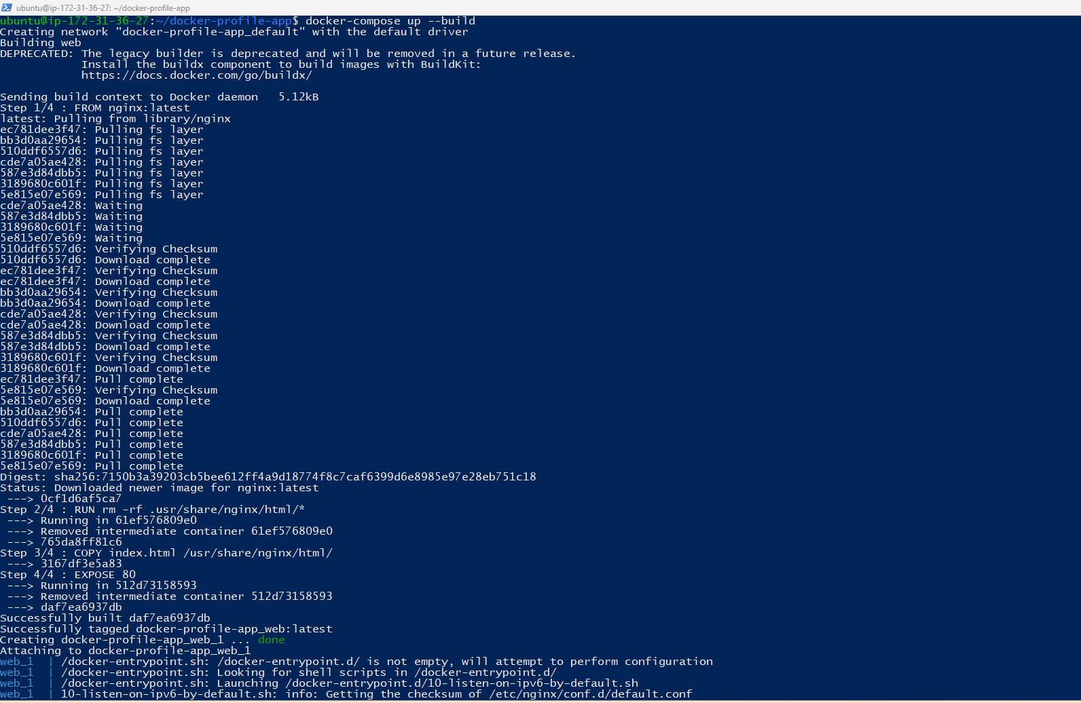
- Tested the docker
- Able to see the Output in the local host.
